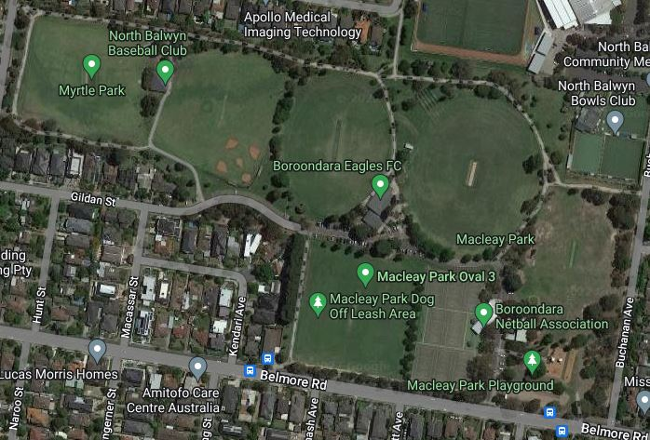



**START 3K**

**2**

**8**

**7**

**6**

**5**

**4**

**3**

**1**

**PLEASE MAKE SURE COMPETITORS HAVE NUMBERS ON LEFT HAND AND UNDERLINE THE BOTTOM OF THE NUMBER**

**TOILETS**

**START 5K**

**FINISH**

**SHORT COURSE**

**LONG COURSE**

**CHECK POINTS**

**3KM COURSE: ALL FEMALE AGES. BOYS AGES 12-13, 14 AND 15 - SHORT LAP ONE + LONG LAP ONE**

**5KM LONG COURSE MALES, 16 AND 17-20 YRS. - SHORT LAP ONE + TWO LONG LAPS.**

**CROSS COUNTRY COURSE : MACLEAY/MYRTLE PARK—NORTH BALWYN**